Ideation Phase Empathize&Discover

|  |  |
| --- | --- |
| Date | 25july2025 |
| TeamID | PNT2025TMID09231 |
| Project Name | VisualizingHousingMarketTrends:AnAnalysis of Sale Prices and Features using Tableau |
| MaximumMarks | 4Marks |

**EmpathyMapCanvas:**

An empathy map is a simple, easy-to-digest visual that captures knowledge about a user’s behaviours and attitudes.

Itisausefultooltohelpsteamsbetterunderstandtheirusers.

Creating an effective solution requires understanding the true problem and the person who is experiencing it. The exercise of creating the map helps participants consider things from the user’s perspective along with his or her goals and challenges.

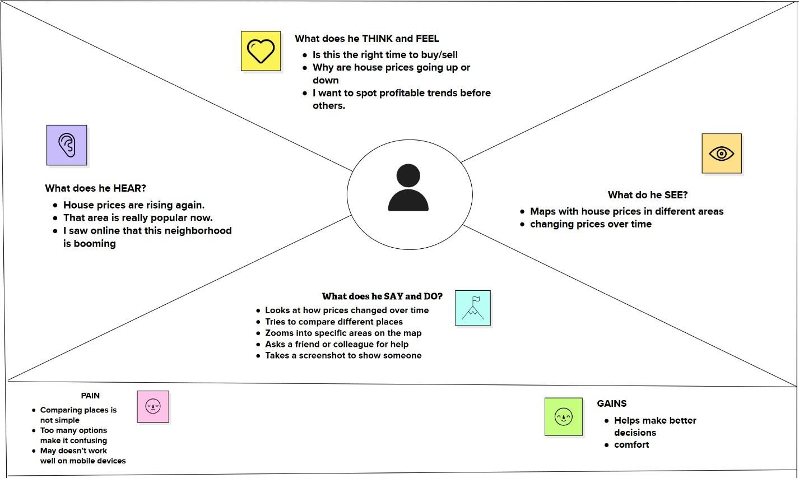

Reference:<https://www.mural.co/templates/empathy-map-canvas>

**Example:FoodOrdering&DeliveryApplication**

